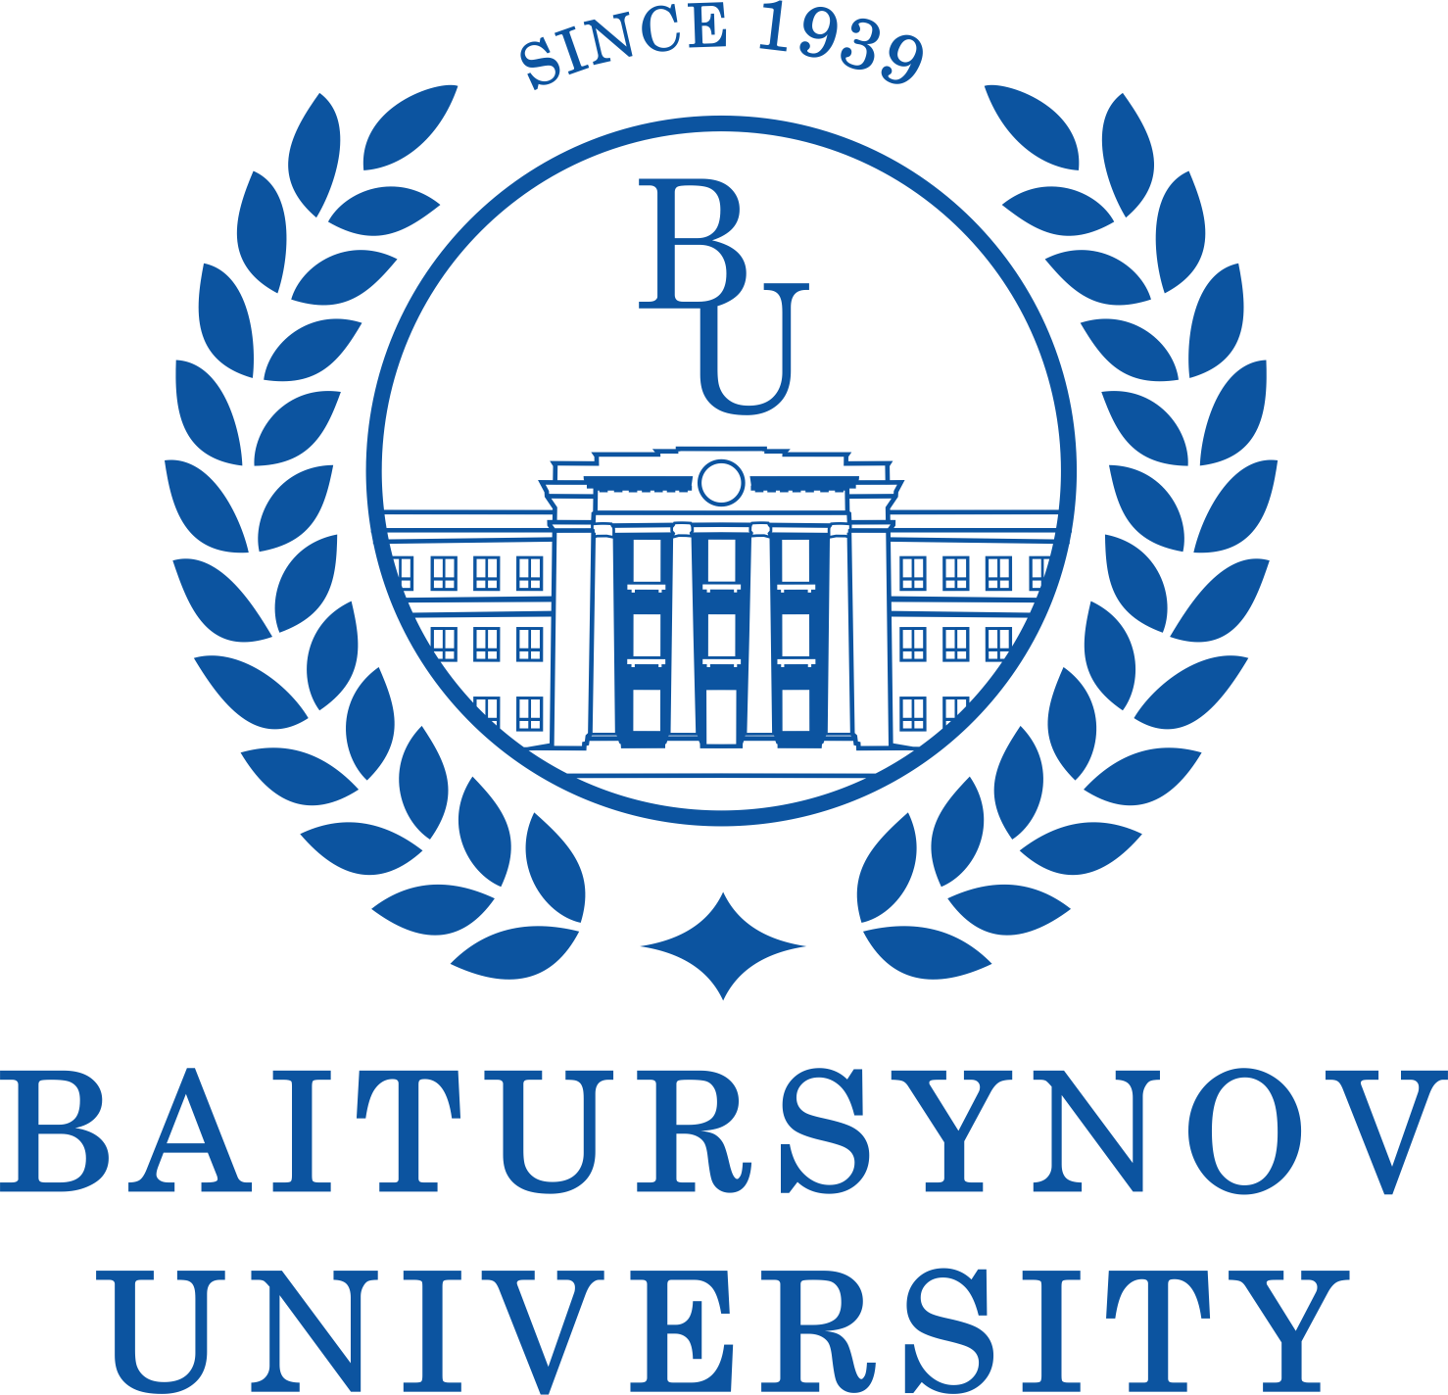
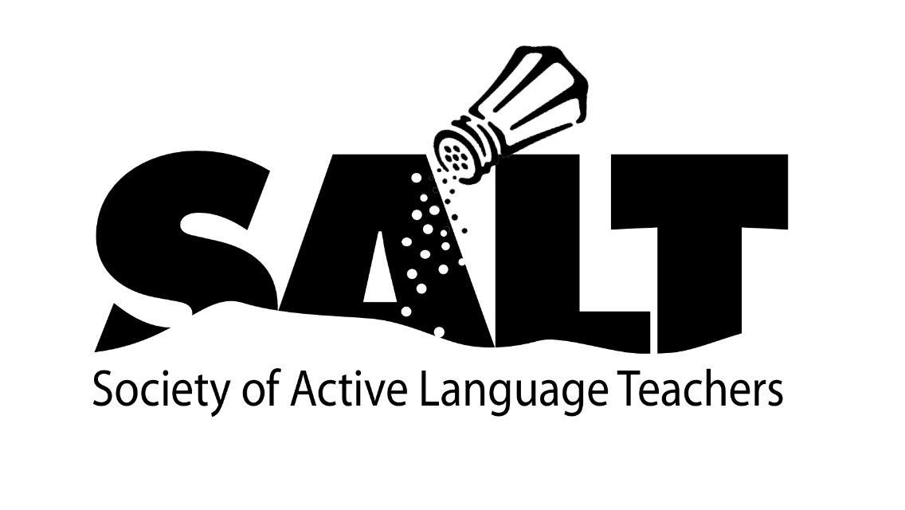

CALL FOR PROPOSALS
The Department of Foreign Philology at A. Baitursynov Kostanay Regional University invites you to participate in International Student Conference on Applied Linguistics “Research. Opportunity. Language. Experiment - ROLE”
The conference gives participants the opportunity to present and share knowledge in the proposed fields of research and enhance written and oral communication skills through a series of challenging offline sessions and activities. Various formats of presentation are aimed at fostering skills in doing scientific research in different aspects of Applied Linguistics.
Languages of the conference: English, French, German.
Our conference will have two components:
In-Person and Video Library
Our in-person conference will be held at the main building of A.Baitursynov Kostanay Regional University on December 9st 2022, followed by re-recorded sessions starting on December 9^{st,} 2022 through May 1, 2023. Proposals can be submitted for an in-person presentation, a pre-recorded presentation for the online, or a combination of both. As you fill out the “Call for Proposal” form you will indicate the type and the format of the proposed presentation.

The presentation topics include:
1. Didactical Innovations;
2. Modern Trends in Translation;
3. Literature and country studies;
4. Second language acquisition (French, German);
5. Information literacy and academic writing;
6. General issues of Linguistics.
7. Word and Grammar
8. Public Speaking
Presentation Formats
§ In-Person Presentations/Panels will have an assigned day, time, and room. You will present following the type of presentation you choose. Before the conference, you will receive a letter with the explanation

§ Video Library Presentations should be 10-to-15 minutes in length. All pre-recorded video library presentations will be a part of the library for participants to view at their leisure starting on December 5th. It will NOT have a scheduled time or day.
o There is NO Q&A. You must feel comfortable with technology recording your presentation.
o All pre-recorded videos are due by November 26th.
o All accepted videos will become the property of the Department of Foreign Philology at A. Baitursynov Kostanay Regional University to share in the future if they so choose
Presentation Types
§ Presentations: Presentations can be a workshop, a demonstration, a session about teaching tips, or a presentation about research. Duration is 30 minutes

§ Panel Presentation: Explore a particular topic from different perspectives.
o Up to 3 panelists per panel. You will have 10 minutes to present. You will have 2 co-presenters. In total, you will have 50 minutes for 3 presentations and 20 minutes to answer the questions.

§ Poster Sessions – A poster session is a visual representation of a best practice, successful activity, or researched evaluation that is presented to small groups of attendees in the Poster Session area of the conference.
o Limited to one presenter.

General Information for all Presenters
We thank you in advance for your interest in participating in our conference and your diligence in completing the proposal form.
Please thoroughly review the Presenter Guidelines before submitting your proposal.
Each step MUST be followed.
1. Submission: The proposal deadline is November 30, 2022
§ Proposals received after this date will not be considered.
§ You should receive an email within a week after you submit your proposal acknowledging your submission.
2. Notification: On or about December 3, 2022
§ Each presenter involved in the presentation will receive an email notification on or about December 3, 2022, as to the acceptance and guidelines on the participation. Please watch for this email. In this email, you will see the type of presentation (In-Person, Video Library) that you have been assigned.
§ Tools and guidelines for creating the video of your presentation will be included in the acceptance emails.
§ Save this email. You will need to refer back to it when filling out the registration form
3. Pre-Recorded Videos for the Video Library: due by December 5, 2022.
§ Follow the guidelines and procedures supplied to record your 10-15 minute presentation.
§ Upload presentation by November 26, 2022.
Please follow the steps
1. Submit the proposal by November 30th, 2022: https://forms.yandex.ru/u/63692d99eb614688e07defae/
2. Look for notification of acceptance around December 3rd, 2022.
3. Submit Video Library Presentations by December 5th, 2022.

All participants will receive certificates.

