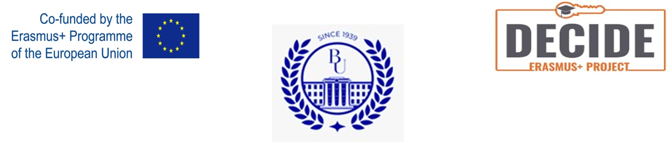

Report
On II Ten Days Period of Awareness of the Needs of People with Disabilities
"From the Days of Awareness to the Inclusive Society"
held in Kostanay region by A.Baitursynov Kostanay Regional University

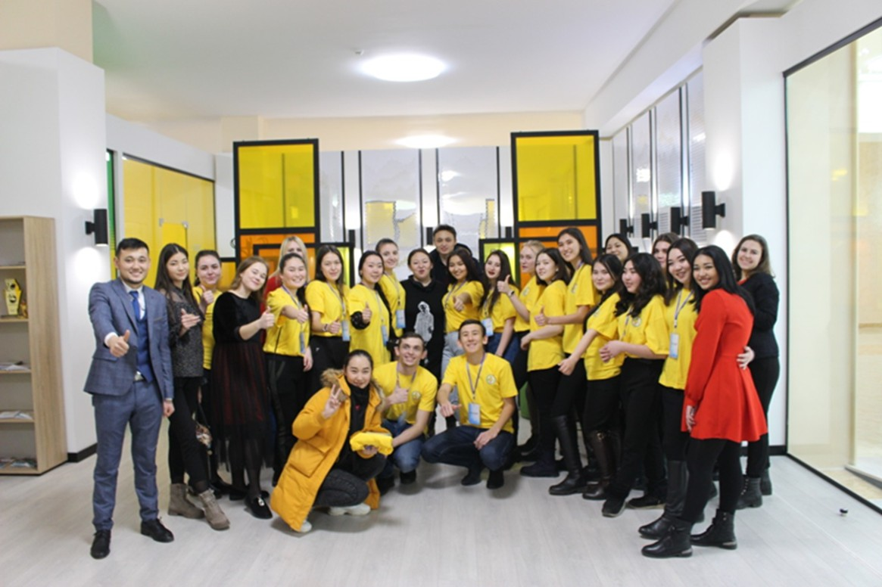

In Kostanay region the Second Ten Days Awareness Period "From the Days of Awareness to the Inclusive Society" from October 7 to October 17, 201-1, organized by teachers of the Department of Psychology of А. Baitursynov KRU, working group of the Erasmus+ project DECIDE "Development of services for individuals with disabilities" 598661-EPP-1-2018-1-RO-EPPKA2-CBHE-JP https://www.facebook.com/watch/?v=2385017474962811.
https://www.facebook.com/watch/live/?ref=watch_permalink&v=4380181108717246
https://www.instagram.com/p/CU4farTqLi3/?hl=ru
https://kstnews.kz/newspaper/1123/item-71461 – interview in the regional newspaper “Kostanaiskiye novosti” about Awareness Days
https://uchitelskaya.kz/vse-rubriki/kolledzhi-and-vuzyi/raznyie-vozmozhnosti-ravnyie-prava
With the information support of the Akimat's Internal Policy Department of Kostanay Region the Second Ten Days Period "From the Days of Awareness to the Inclusive Society" began with a briefing at the Regional Communications Service. The briefing was moderated by Professor L. V. Sarkisyan, coordinator of the DECIDE project at A.Baitursynov KRU. During the briefing explanations were given on the implementation of the the Ten Days Awareness Period and topical issues of the development of an inclusive society.
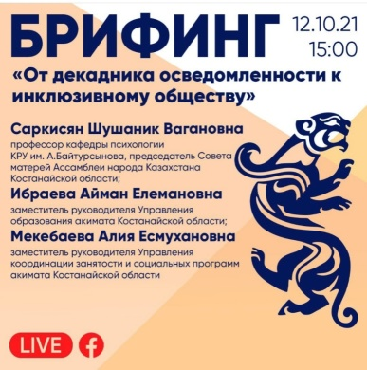
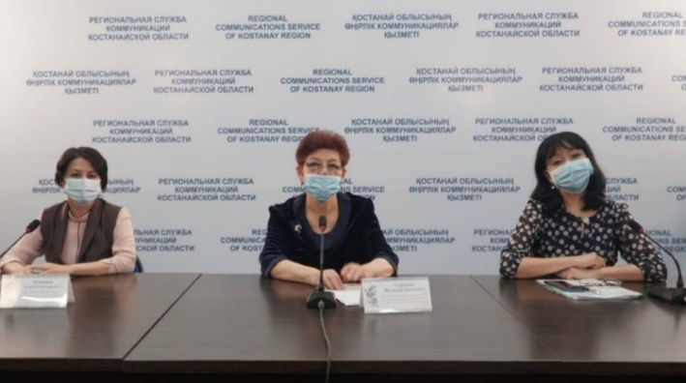

Purpose of the II Ten Days Awareness Period consisted of carrying out awareness-raising work on the formation of an inclusive culture and a non-discriminatory tolerant attitude of society towards people with disabilities. This goal fully reflects the priorities of the social policy of the Republic of Kazakhstan.

Organizers II Ten Days Awareness Period, L.Sarkisyan and I.Parkhomenko carried out a lot of organizational and methodological work with the heads-of partner organizations participating in this event; identified the target groups with which various events were planned; agreed on the dates of the Ten Days Awareness Period; organized its methodological support; published a video address of L. V. Sarkisyan to the participants of the Ten Days Awareness Period.

The events of II Ten Days Awareness Period in Kostanay Region were actively supported by the partners and involved 359,541 participants (in I Ten Days Awareness Period – 121724 participants) This number includes pupils of senior kindergarten groups, secondary schools learners, students of colleges and universities, civil servants, the adult population of the region, and representatives of NGOs.

As participating partners II Ten Days Awareness Period included:

Partners, who participated in the first Ten Days Awareness Period and continued this work:
1. State Institution "Education Department of Kostanay region Akimat"
2. State Institution "Education Department of Kostanay"
3. Nazarbayev Intellectual School
4. Council of Mothers of the Kostanay region
5. A.Baitursynov KRU
6. Kostanay Branch of the Academy of Public Administration under the
President of the Republic of Kazakhstan
7. Kostanay L.Tolstoy Regional Universal Scientific Library
8. Kostanay City N. Ostrovsky Library named after
9. NGOs "Kostanay City Voluntary Society of disabled people"
10. NGO "Accessible Education for disabled students"

New partners of II Ten Days Awareness Period in 2021:
1. Kostanay branch of the party "Nur-Otan"
2. State Institution " Department of Internal Policy of Akimat Kostanay region"
3. State Institution " Department of Coordination of Employment and Social Services Programmes of Kostanay region Akimat"
4. State Institution "Health Department of Kostanay region Akimat"
5. State Institution "Department of Culture of Kostanay region Akimat"
6. State Institution "Youth Policy Department of Kostanay region Akimat"
7. NCPC JSC "Orleu" and RCC program of Kostanay region
8. Nazarbayev Intellectual School, Kostanay
9. NGO "Alliance of Women's Forces"
10. Youth Resource Center Kostanay region
11. Public organization of mothers of children with disabilities "Raduga" 12. Advertising agency "Repaco"
13. Sponsors
14. Volunteers
Thus, the number of participating partners is II The Ten Days Awareness Period increased by 2.4 times.
Фото методички????
A group of teachers and psychologists on volunteer basis led by L. V. Sarkisyan, project coordinator Erasmus+ DECIDE at ABKRU developed methodological Handbook - recommendations for extracurricular activities (lessons of Kindness, online and offline class hours "Learning to live together" "Children need to learn place") for the kindergarten students of classes I-IV, V-VII classes VIII-IX class X class XI and College students. The Handbook was developed in the Kazakh and Russian languages. It was sent to all kindergarten and education organization. This is a great achievement of teachers and psychologists in School No. 29 Karamkasova K. P. and School No. 23 Khizhnyak I. Yu., who developed this collection on a volunteer basis.
Фото статьи в газете с интервью Л.В. Саркисян
The manual was preceded by a lengthy introductory article by L. V. Sarkisyan, Erasmus + DECIDE project coordinator on the goals II Ten Days Awareness Period and its history in Kostanay Region, Kazakhstan. .

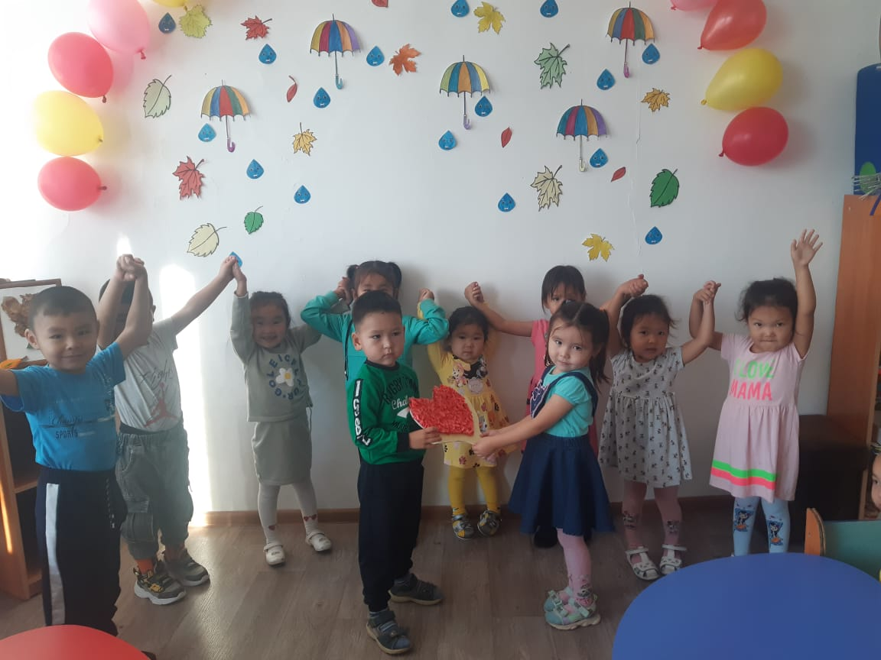
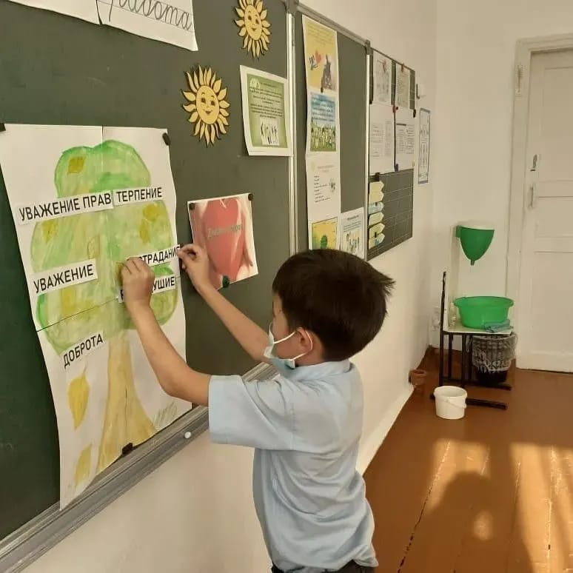

Thus, various events were held in 69 kindergartens in Kostanay city with coverage of about 2500 children of senior groups and in 579 kindergartens of Kostanay region - with coverage of about 13 thousand pupils of senior groups.

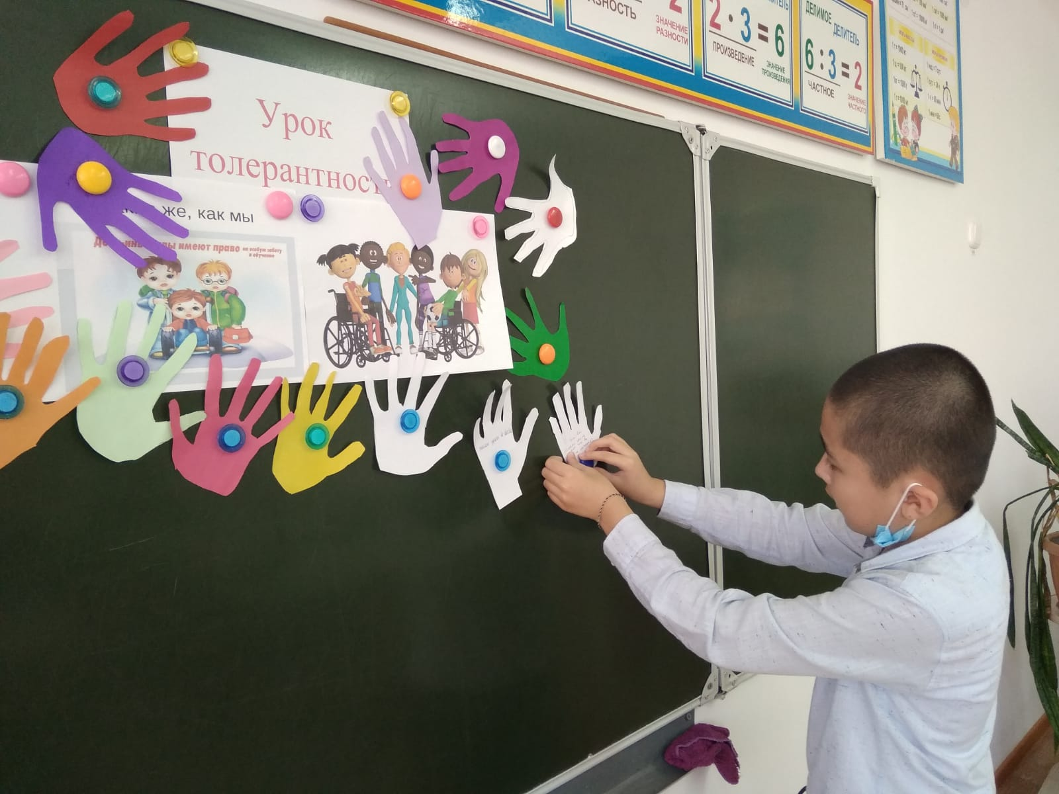

In the 35 schools of Kostanay more than 3,2 thousand students participated in offline and online class hours; in 477 schools of Kostanay region 107,800 people (including teachers, representatives of the parent community, and members of school boards of trustees) participated in the events.
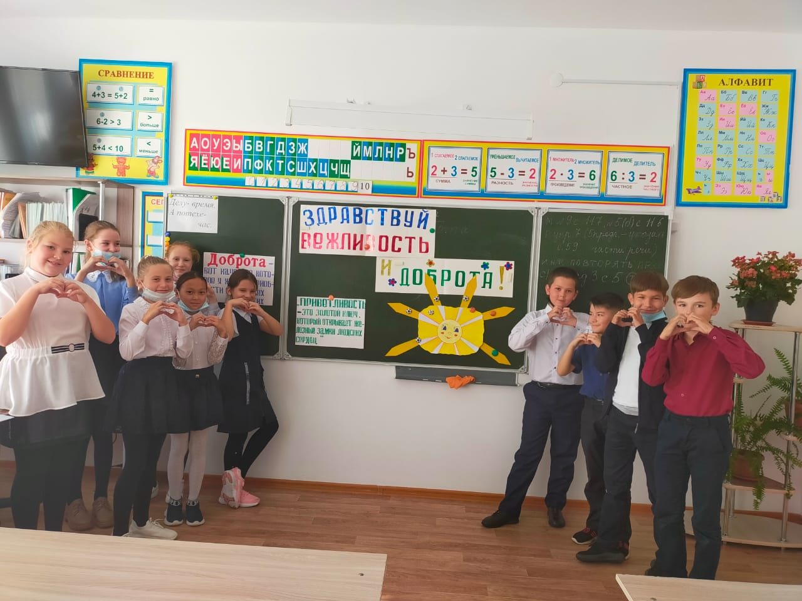

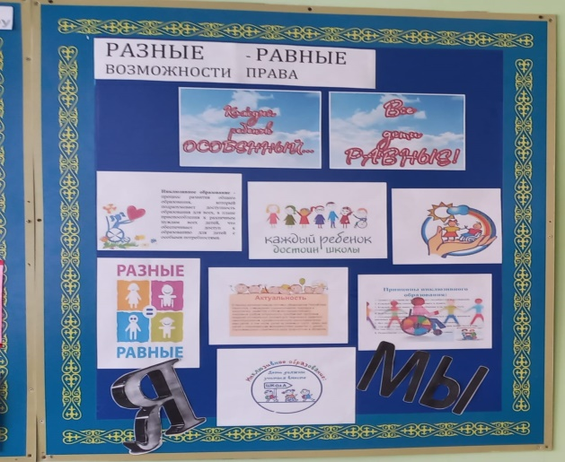
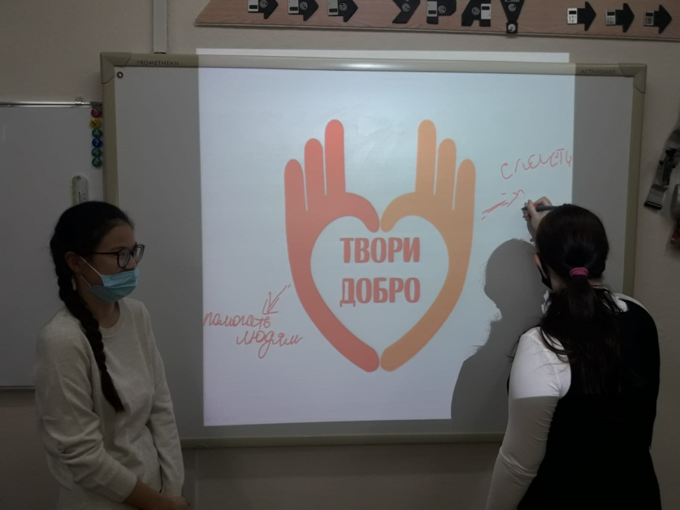

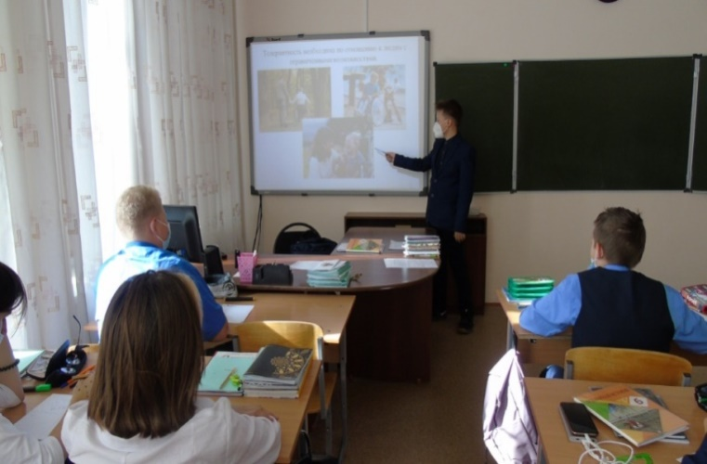
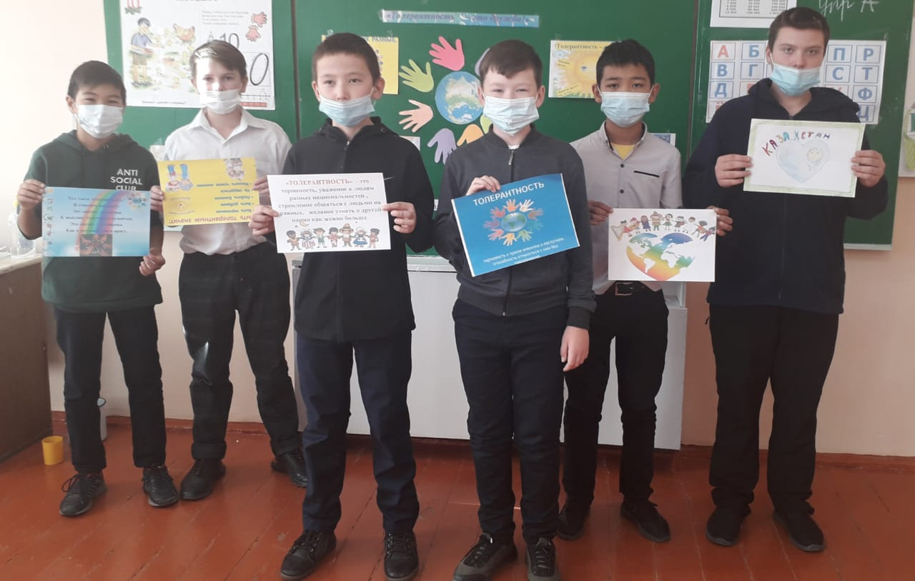

ФОТО колледжей, мед.работников Special events were held in all 34 colleges of the region, in which more than 11,000 students participated. The topics of curatorial hours were very diverse depending on the profile of the college, in addition, meetings were held with medical professionals, communication trainings on the formation of a culture of communication with people with disabilities, students participated in choral singing using sign language; teachers were given methodological advice on studying recommendations aimed at developing inclusive education.

II Ten Days of Awareness PERIOD AT A.Baitursynov KRU

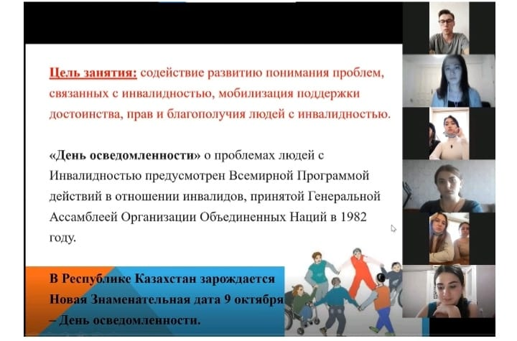
In A.Baitursynov KRU 94 students groups held offline curatorial hours "We are different – We are equal – We are together", in which 1,922 students participated. In some groups, very sincere and interesting conversations were held, during which students had lively discussions. With the help of training exercises, students tried on roles of persons with disabilities and experience the emotions and feelings that these people experience.

Students highlighted the main thing that the topic of disability is complex and it is important to try to debunk the stereotypes that disability is a problem of people with disabilities themselves, and not a problem of society as a whole. From the point of view of students, so far the main problem is the barrier environment. Students believe that they can contribute to the elimination of such socio-psychological barriers as prejudice, non-tolerant attitude towards people with disabilities, by actively participating in volunteer activities for the development of an inclusive society.
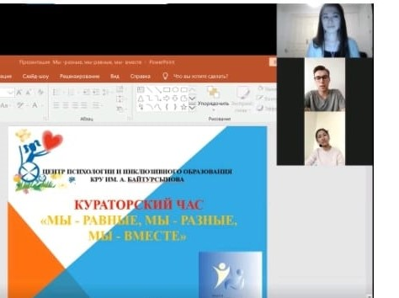
According to the general opinion of students, there are a lot of equally important aspects that are not yet given enough attention. These are: employment of people with disabilities, problems of people with mental disorders, hearing and visual impairments. Students voiced their views, discussed the possibility of exercising the rights of students with disabilities in the University and came to the conclusion that people with disabilities are strong and dedicated people, there are people who understand that life is precious, all students should study together, students with disabilities should be the part of the students community.

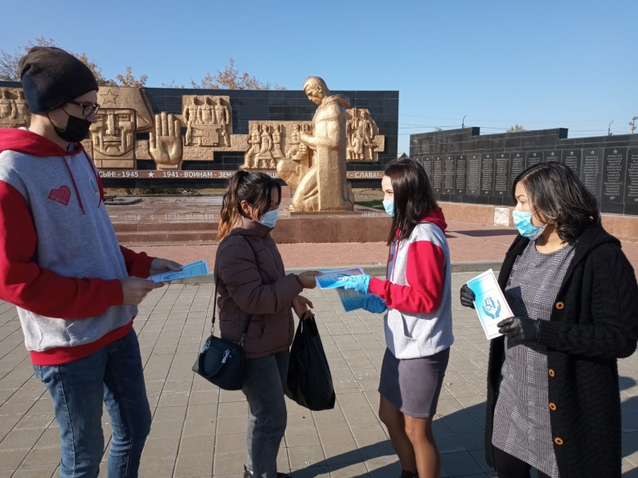

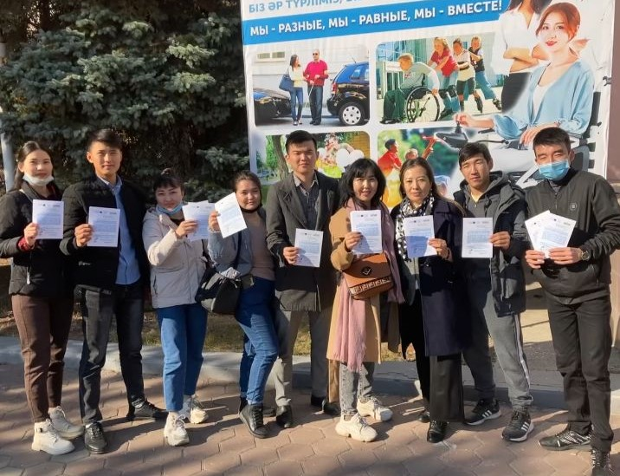

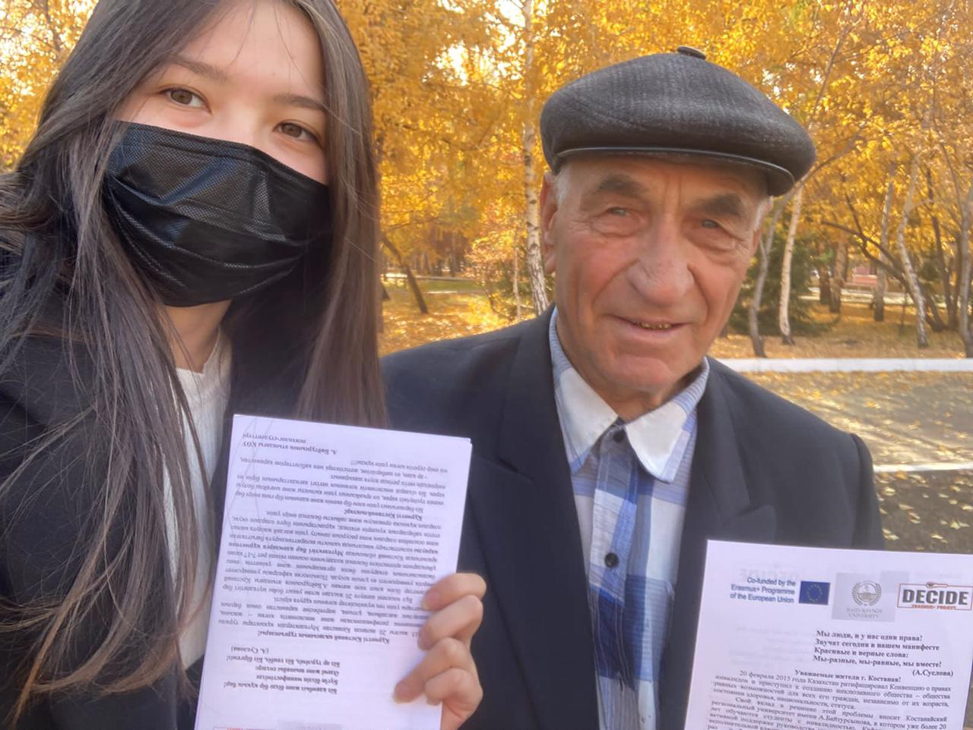
In addition, students-psychologists of A.Baitursynov KRU took an express interview on the streets of Kostanay city. 1000 flyers in Kazakh and Russian languages were distributed in Kostanay on the issue of public awareness about the development of inclusion. Respondents were asked to answer the following questions:
- Have you ever interacted with people with disabilities?
If so, where? What do you know about their lives, their problems?
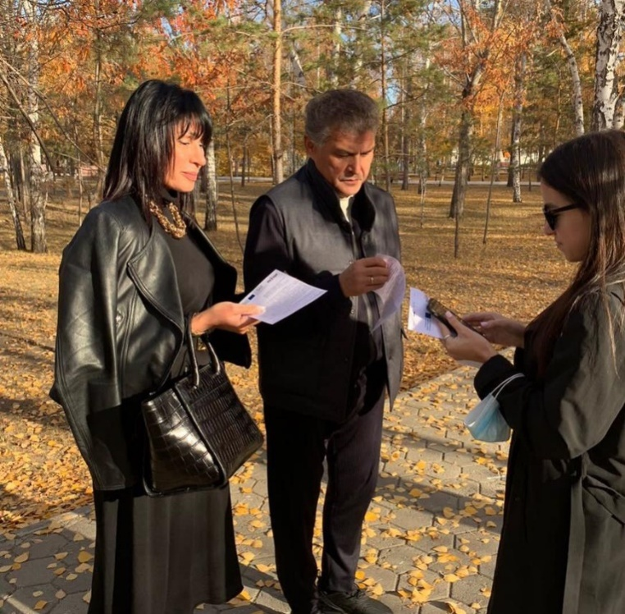
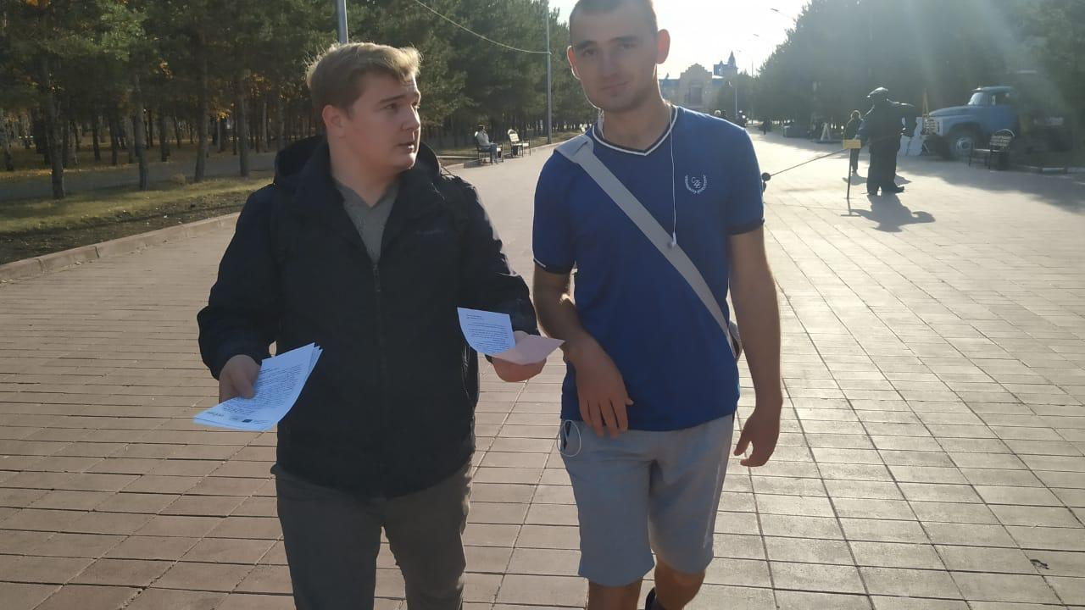
- How would you assess the life quality of people with disabilities? (on a 5-point scale, where 5 is excellent and 2 is unsatisfactory, etc.)
- For the last 5 years, children with disabilities have been studying in a regular school. Do you think this is right or wrong? Good or bad?
What do you think government employees, you, and your friends, relatives, and others can do to make life more comfortable for people with disabilities?
The survey revealed the need to strengthen awareness-raising activities, especially in terms of recent changes to the regulatory legal acts of Kazakhstan on inclusion and the formation of a humane attitude towards people with disabilities in society.
Conducting an express interview was reflected in the development of 2 social videos in Kazakh edited by psychology students and under the guidance of Parkhomenko I. A. DECIDE project trainer/researcher. https://ksu.edu.kz/newslist/university-life/my-raznye-my-ravnye-my-vmeste/
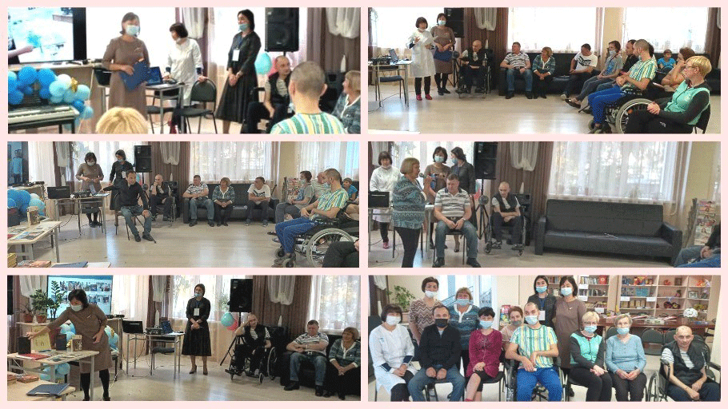

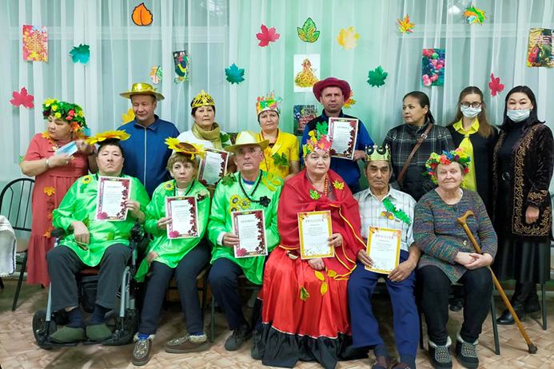
II Ten Days of Awareness Period in cultural organizations

The Activities of II Ten Days of Awareness Period were actively supported by the Kostanay region Akimat's Department of Culture. All work with libraries was coordinated by the L. N. Tolstoy Regional Library. 3 regional libraries, 14 city libraries, 16 district libraries and 21 rural libraries, totally 54 libraries participated in the events.

The events were held both in libraries and Cultural Centres of Kostanay region. It is important, that information and explanatory work was carried out in 21 rural libraries with residents of the most remote settlements. The total coverage of representatives of target groups was more than 3 thousand people. Participants of the actions "You are not alone in this world", "I look at the world not with the eyes but with my heart I feel it", as well as members of forums discussed the ways and forms of closer cooperation between people with disabilities and healthy individuals; these are the participants of the meeting with representatives of local Executive bodies. The library photo gallery "Burning light” and exhibition of creative works of children with disabilities "My independent Kazakhstan" in Naurzum district were organized. Visitors to the personal exhibition of a disabled child Zhanara Yerzhanova "There are no barriers to creativity" in Zhitikarinski district Library.
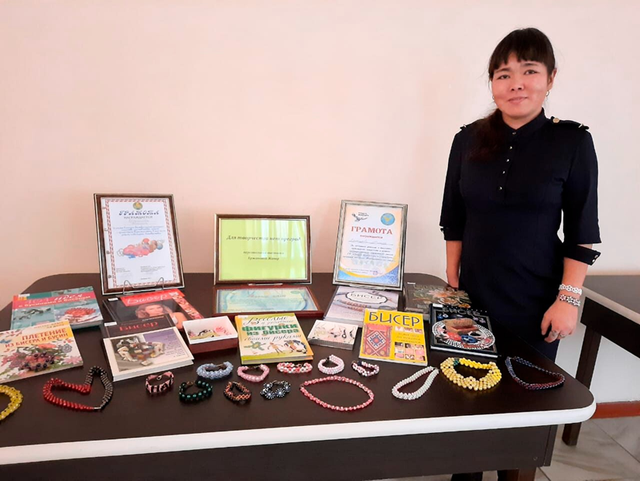
Information about the events held is available on social networks and on the websites of regional, city, district and rural libraries, as well as Departments of Culture and Language Development in cities and districts of Kostanay region. https://www.facebook.com/permalink.php?story_fbid=2738523146440447&id=100008483641812

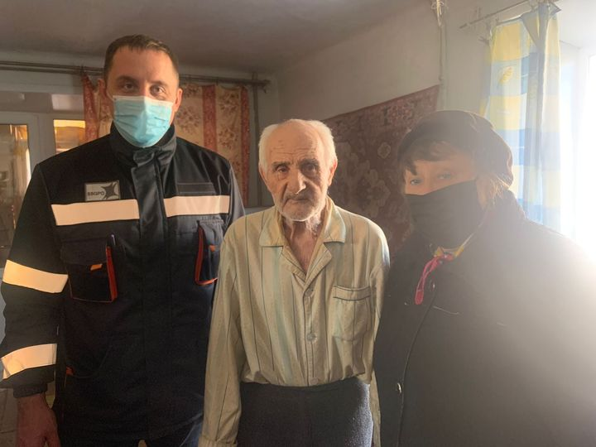
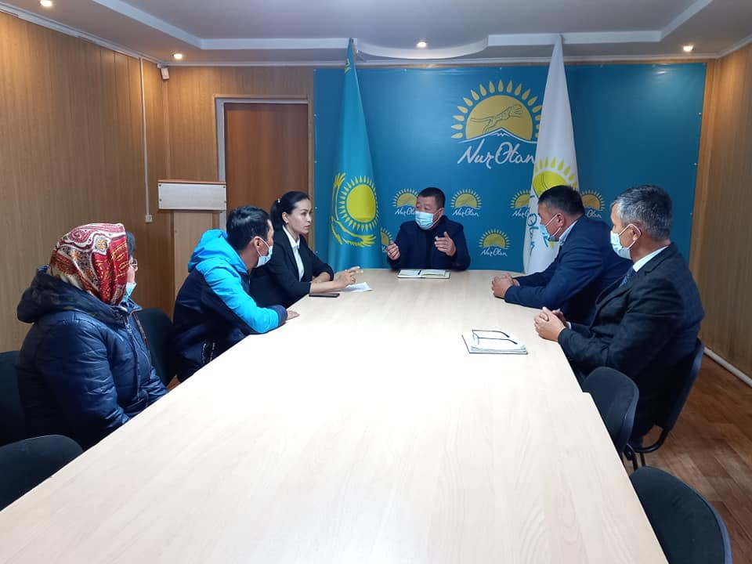

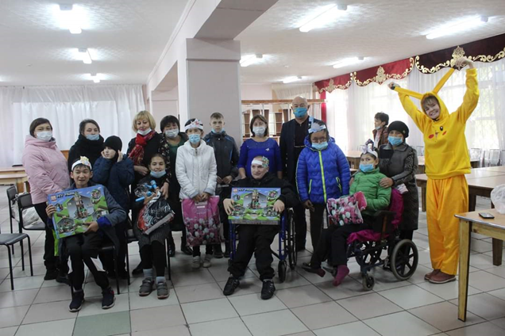
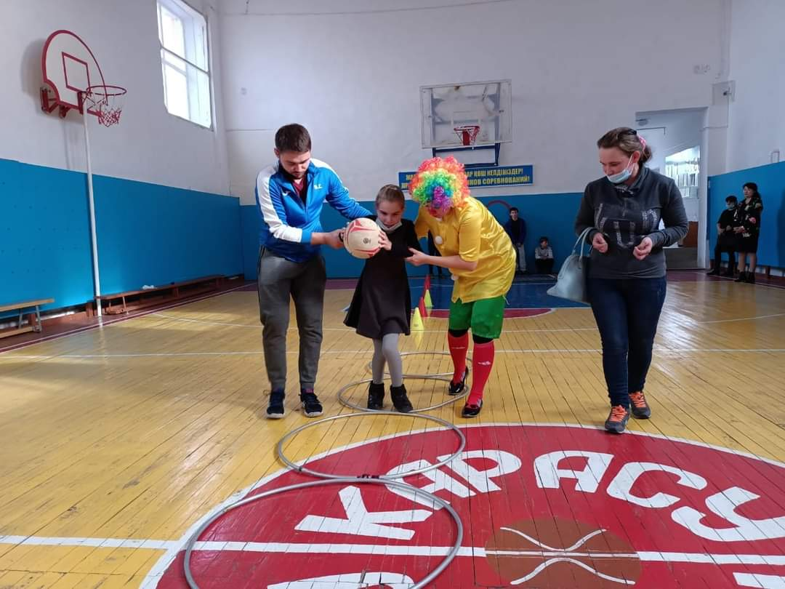
. https://orley-kost.kz/index.php/ru/news/4714-dekadnik-osvedomlennosti-mir-bez-granits

II Ten Days of Awareness Period in Kostanay regional branch of the Nur-Otan party

The Kostanay branch of the Nur-Otan party actively participated in II Ten Days of Awareness Period by organizing events such as:
* Round tables on the topics "Equal rights-equal opportunities", "Development of an inclusive society and culture", "Social equality-a sign of a mature state";
* dialogue panels on the development of inclusive culture with the participation of public representatives and civil servants;
* field meeting on "Integration of disabled children into society" with the participation of representatives of the city's public council at Lisakovsk;
• members of the Nur-Otan party held awareness-raising events on the topic "We are different-we are equal-we are together", as well as organized an offline reception of citizens in Nur-Otan district branches of Nur-Otan;
• Sports сcompetitions involving children with disabilities were held.
The total number of participants is 507 people.
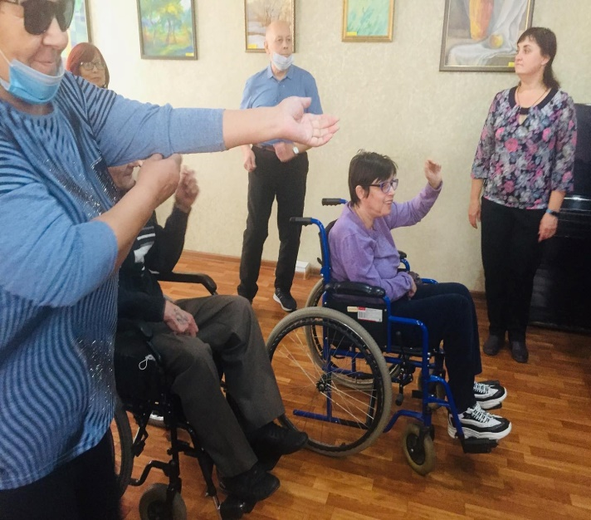
Information about II Ten Days of Awareness Period was posted on the official websites of the Nur-Otan party, as well as published in various social networks.
Suggestions:
1. Information and explanatory work on the formation of a tolerant attitude of society towards people with disabilities should be carried out comprehensively, on a systematic basis.
2.To create an inclusive society, the Days of Awareness should include activities aimed at integrating people with disabilities, especially children, into society.
3.To improve interaction with representatives of target groups, it is recommended to practice field meetings in the regions, with the participation of specialists of various profiles (doctors, teachers, social workers, etc.). employees), members of the public, deputies of maslikhats.

II Ten Days of Awareness Period in a public association
Alliance of Women's Forces
The Women's Forces Alliance made a significant contribution to the II Ten Days of Awareness Period in Kostanay region.
Various events were held in Kostanay region during the Days of Awareness Period:
- monitoring the satisfaction of people with disabilities with the quality of social services they receive and the availability of education for children with disabilities;
- round tables with stakeholders of different level, dialogue platforms with the participation of people with disabilities,
- master classes, discussions of "Inclusive culture in our life",
- visiting people with disabilities at home,
- concerts, charitable assistance to people with disabilities (30 people received homemade first aid kit; 40 people - food packages, 119 - tea bags).
In all events held by the Women's Forces All in districts and cities of Kostanay region the local executive bodies and non-governmental organizations, as well as volunteers and sponsors participated.

II Ten Days of Awareness Period
in the Youth Policy Department Kostanay region
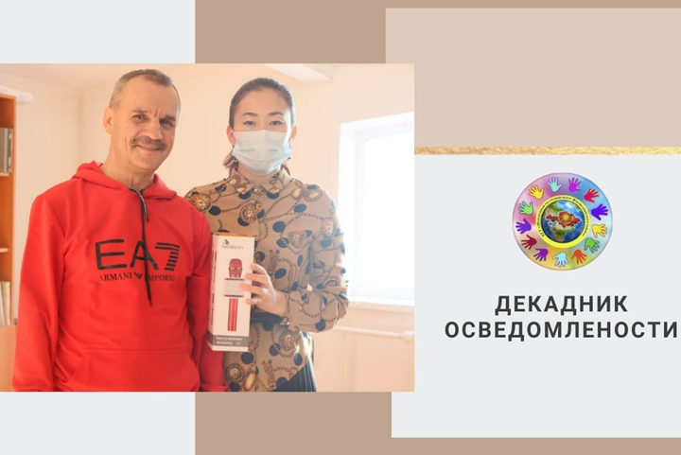

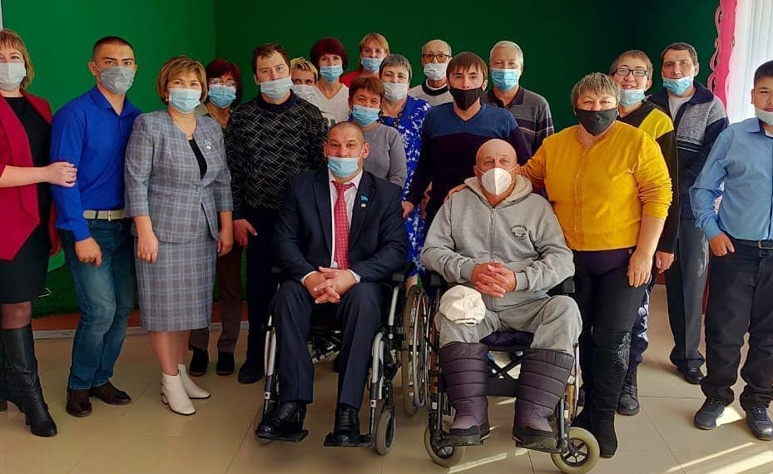
The Department of Youth Policy of the Akimat joined II Ten Days of Awareness Period with its own divisions: Youth Resource Center,
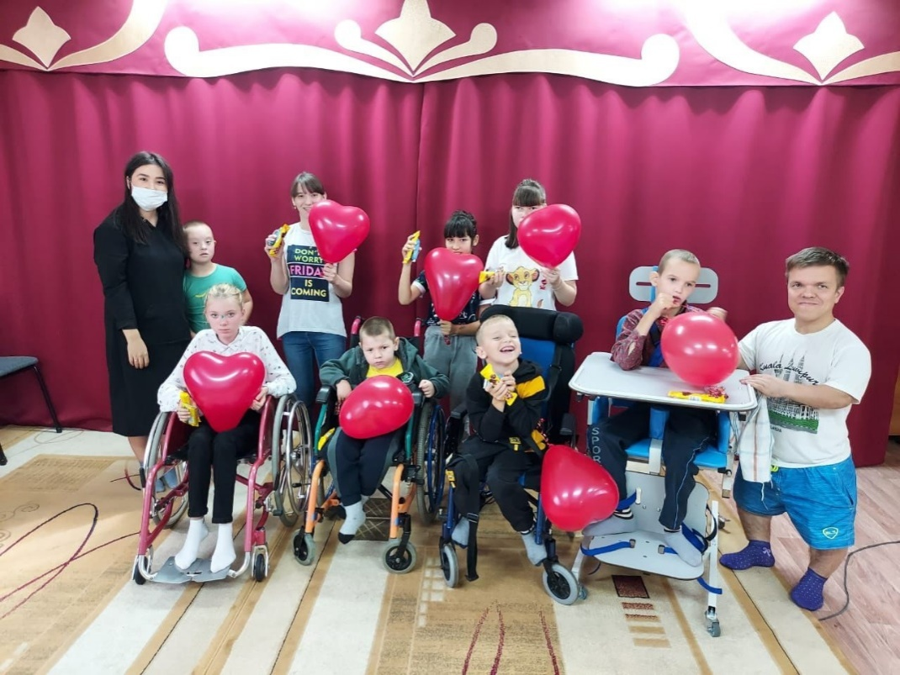
The volunteer Center held actions "Social equality-a sign of a mature state", the dialogue platforms, meetings with deputies, trainings, master-classes, concerts were organized, and thematic flyers were distributed at many events. Representatives of the Youth Resource Center, together with volunteers, visited people with disabilities in their place of residence in order to provide them with assistance. In addition, a video contest "My Special Friend" was held among college students. All the work carried out in the framework of the Awareness Days was widely covered on the radio, in local print media and social networks. Coverage of representatives of target groups is 406 people.

II Ten Days of Awareness Period in Kostanay branch of “Academy of public administration under
the President of the Republic of Kazakhstan” in Kostanay region.
Kostanay Branch of “Academy of public administration under the President of the Republic of Kazakhstan”, as a partner in the DECIDE project, during Ten Days of Awareness Period carried out purposeful work on the formation of the state budget. employees -trainees of the branch of inclusive thinking and culture of communication with people with disabilities, on October 7, 2021, an interactive discussion "What you need to know when communicating and interacting with people with disabilities, depending on their characteristics was held in the branch.

II Ten Days of Awareness Period on Mothers' Council of Kostanay Region and the Regional
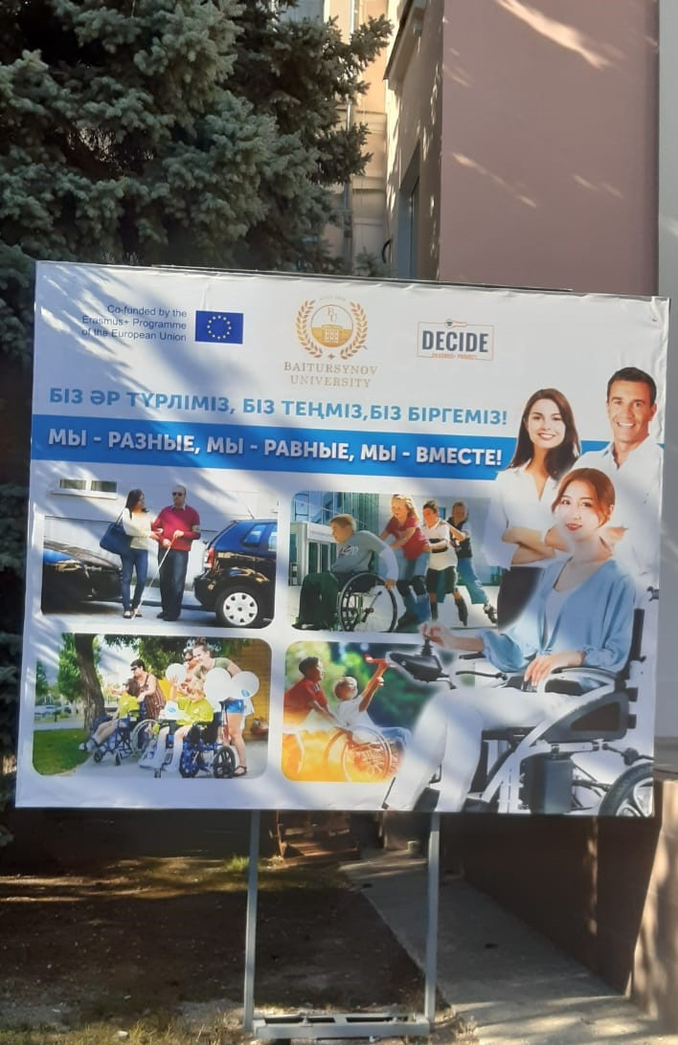
Communication Service
Council of Mothers of the Kostanay region together with the Regional Communication Service, being a permanent project partner Erasmus+ DECIDE "Development of services for people with disabilities":
- developed the banner "We are different – We are equal – We are together" and in partnership with an advertising agency "Repaco" installed it next to the A.Baitursynov KRU;

District and city Councils of Mothers of Kostanay region (20 councils in total) conducted a large awareness-raising campaign among the population on the problem of developing an inclusive society, preparing and publishing 14 articles in local media and social networks;
- on a voluntary basis, the House of Friendship organized consultation work on the issues of law and psychology as well as mediation.

November 4, 2021 by project coordinators Erasmus+ DECIDE "Development of services for people with disabilities" was organized and conducted online Round table "From Awareness Day to Inclusive Society" based on the results of the II Ten Days of Awareness Period in Kostanay region. It was attended by 97 people, including project partners, civil servants-managers and specialists of local executive bodies, deputies Kostanay regional Maslikhat, representatives of educational and health organizations, representatives of the rector's office of A.Baitursynov KRU, parent community, members of the Mothers' Councils of Kostanay region, NGOs, library staff, people with disabilities, student volunteers, media representatives, sponsors.

Conclusions:

1. Purpose and objectives of II Ten Days of Awareness Period in the Kostanay region, conducted as part of the project DECIDE "Development of services for people with disabilities", were fully achieved at a high organizational and methodological level, with 359,541 participants.
Compared to I Ten Days of Awareness Period (2020) we observe a 3,5-fold increase in the number of target group representatives who participated in the II Ten Days of Awareness Period. This is due to the fact that, firstly, the number of partners of the II Ten Days of Awareness Period increased in 2.4 times, including 11 organizations and NGOs at the regional level; secondly, a significantly larger number of teachers, psychologists, representatives of the parent community and boards of trustees of educational organizations joined in the implementation of II Ten Days of Awareness Period project. Third, the organizers and participants of the II Ten Days of Awareness Period actively used the telecommunications technologies in order to disseminate up-to-date information (information was posted on 7 digital platforms).
2. Conducting Ten Days of Awareness Period is relevant for developing inclusive society.
3. Information about the event II Ten Days of Awareness Period has been made available to the general public:
- with the support of the regional communication service, it is posted on social networks on 7 platforms, information and video materials are posted on the websites of partner organizations (21), 3 articles are published in regional print media 3(Kostanay news; Uchitelskaya+; Kostanay-Agro and a live briefing with project coordinator L. V. Sarkisyan was held in the Regional Communications Service; 14 statistics were published in the regional media and on the official websites of local executive bodies14 статей; in addition, a large number of publications were published during the Decade. informational posts in social networks (In contact; Facebook; Instagram; Odnoklassniki, Telegram).
Students -psychologists of the A.Baitursynov KRU on the streets of Kostanay held an express interview on the issue of public awareness of the development of inclusion in Kazakhstan and 1000 thematic flyers were distributed, which were made by sponsors.

As the analysis of the results of our work showed, II Ten Days of Awareness Period of informality meets these requirements, as the number of project partners increased 2.4 times (from 10 to 24), and includes such stakeholders as local executive bodies, NGOs, volunteers and business structures and sponsors. Involvement of all categories of target groups increased 3.5 times.

The activities carried out have become more complex and diverse (quests, challenges, interactive trainings, webinars, telecommunication contests, etc.). Information and explanatory work was organized on the basis of extensive use of the capabilities of telecommunications technologies.

Our positive progress in the implementation of II Ten Days of Awareness Period is the result of joint creative work based on a broad and responsible partnership.

Positive results II Ten Days of Awareness Period inspires optimism and confidence that the creation of an inclusive society is a real prospect for Kazakhstan, the implementation of which will allow every citizen of Kazakhstan, regardless of their physical abilities, to feel equal among equals in a barrier – free environment that allows everyone to realize their personal potential.

